# Assignment 3

Write a program which can store List of Integer values and print all the values using for loop.

**Program:**

**package** assignment3;

**import** java.util.ArrayList;

**import** java.util.List;

**public** **class** Task1 {

**public** **static** **void** main(String[] args) {

// **TODO** Auto-generated method stub

List<Integer> l1=**new** ArrayList<Integer>();

l1.add(12);

l1.add(132);

l1.add(112);

l1.add(1232);

l1.add(100);

l1.add(200);

l1.add(102);

l1.add(1992);

System.***out***.println("Original List:"+l1);

**for** (**int** i=0;i<l1.size()-1;i++)

{

System.***out***.println("List of Integer values: "+l1.get(i));

}

/*for (Integer num:l1)

System.out.println(num);*/

}

}

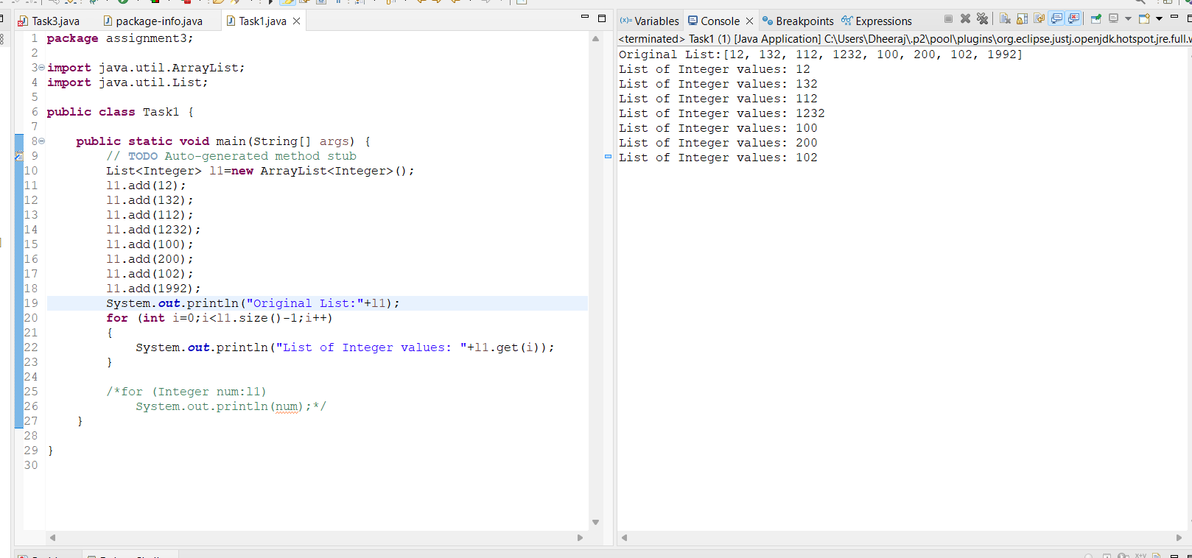

Write a program which can store List of Integer values and print all the values using for loop.

Program:

**Program:**

**package** assignment3;

**import** java.util.ArrayList;

**import** java.util.List;

**public** **class** Task1 {

**public** **static** **void** main(String[] args) {

// **TODO** Auto-generated method stub

List<Integer> l1=**new** ArrayList<Integer>();

l1.add(12);

l1.add(132);

l1.add(112);

l1.add(1232);

l1.add(100);

l1.add(200);

l1.add(102);

l1.add(1992);

System.***out***.println("Original List:"+l1);

**for** (**int** i=0;i<l1.size()-1;i++)

{

System.***out***.println("List of Integer values: "+l1.get(i));

}

/*for (Integer num:l1)

System.out.println(num);*/

}

}



Write a program which can store List of Integer values and print all the values using for iterator

Program:

**package** assignment3;

**import** java.util.ArrayList;

**import** java.util.Iterator;

**import** java.util.List;

**public** **class** Task2 {

**public** **static** **void** main(String[] args) {

// **TODO** Auto-generated method stub

List<Integer> l1=**new** ArrayList<Integer>();

l1.add(12);

l1.add(132);

l1.add(112);

l1.add(1232);

l1.add(100);

l1.add(200);

l1.add(102);

l1.add(1992);

System.***out***.println("Original List:"+l1);

Iterator<Integer> itr=l1.iterator();

**while**(itr.hasNext())

{

Integer num=itr.next();

System.***out***.println(num);

}

}

}

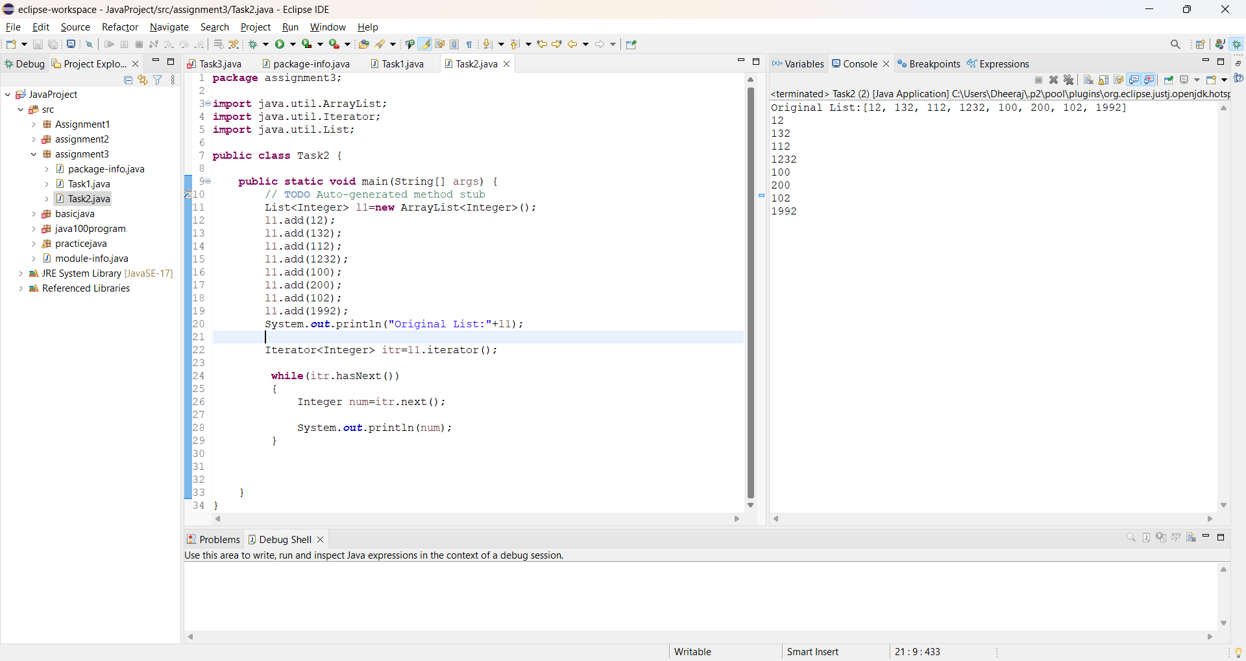

Write a program which will print sum of all numbers which is stored in list.

Program:

**package** assignment3;

**import** java.util.ArrayList;

**import** java.util.Iterator;

**import** java.util.List;

**public** **class** Task3 {

**public** **static** **void** main(String[] args) {

// **TODO** Auto-generated method stub

**int** sum=0;

List<Integer> l1=**new** ArrayList<Integer>();

l1.add(100);

l1.add(100);

l1.add(100);

l1.add(100);

l1.add(100);

l1.add(100);

l1.add(100);

l1.add(100);

System.***out***.println("Original List:"+l1);

**for** (**int** i=0;i<l1.size();i++)

{

sum=sum+l1.get(i);

}

System.***out***.println("Total: "+sum);

}

}

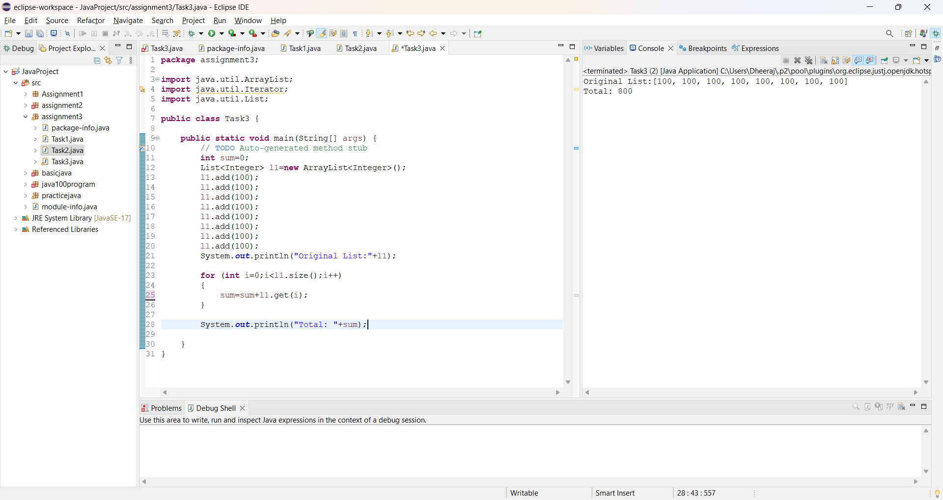

Write a program which will pick the values from Array and Store them List.

Program:

**package** assignment3;

**import** java.util.ArrayList;

**import** java.util.List;

**public** **class** Task4 {

**public** **static** **void** main(String[] args) {

// **TODO** Auto-generated method stub

**int**[] number= {12,13,14,15,16,17,18,19};

List<Integer> l1=**new** ArrayList<Integer>();

**for** (**int** i=0;i<number.length;i++)

{

l1.add(number[i]);

}

System.***out***.println(l1);

}

}

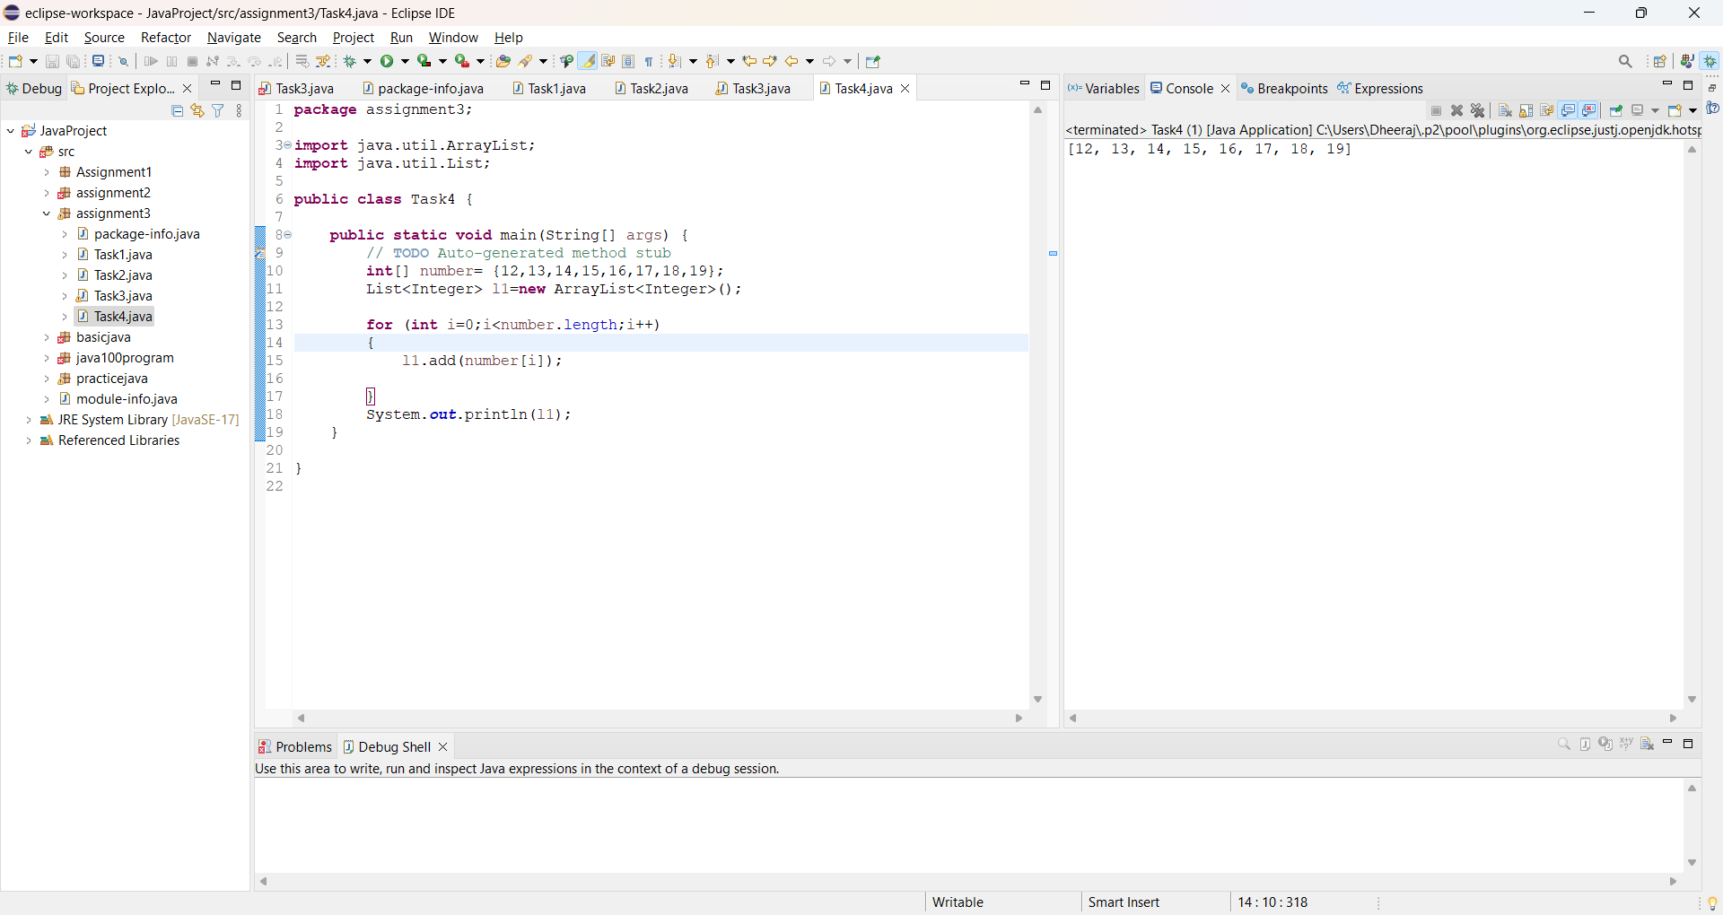

Create a list of numbers 33,44,55,66,77,88 and perform below operation

Remove second element from list using index

Remove second element from list using value

Add 90 at index 3

Get the length of list

Print all values from list using any values

Convert List into array.

**Program:**

package assignment3;

import java.util.ArrayList;

import java.util.List;

public class Task5 {

public static void main(String[] args) {

//33,44,55,66,77,88

List<Integer> l1=new ArrayList<Integer>();

l1.add(33);

l1.add(44);

l1.add(55);

l1.add(66);

l1.add(77);

l1.add(88);

System.out.println("Original List:"+l1);

//Remove second element from list using index

l1.remove(1);

System.out.println("After Removing 2nd Element:"+l1);

//Remove second element from list using value

int elementToRemove = 55;

int indexToRemove = l1.indexOf(elementToRemove);

if (indexToRemove > 0 && indexToRemove < l1.size()) {

l1.remove(indexToRemove);

}

System.out.println("After Removing second element from list using value"+l1);

//Add 90 at index 3

l1.add(2, 90);

System.out.println("Add 90 at index 3"+l1);

//Get the length of list

System.out.println("Length of list:"+l1.size());

for (int value : l1) {

System.out.println("Print all values from list using any values:"+value);

}

//Convert list into array

int[] arr = l1.stream().mapToInt(i -> i).toArray();

System.out.println("List into array"+l1);

}

}

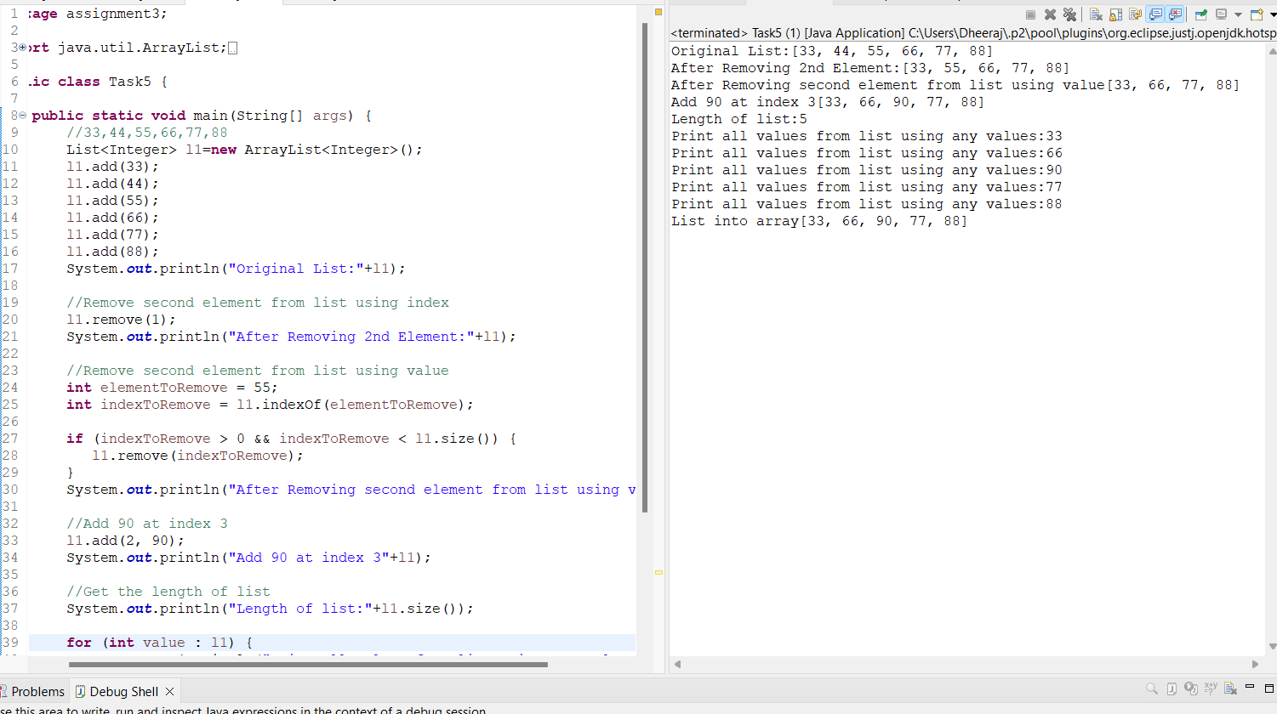

Write a program which will display true if list contains Mobile else prints false

List - Web Automation, API Automation, Mobile Automation.

Output – True

Program:

**package** assignment3;

**import** java.util.ArrayList;

**import** java.util.List;

**public** **class** Task6 {

**public** **static** **void** main(String[] args) {

List<String> l1=**new** ArrayList<String>();

l1.add("Web Automation");

l1.add("API Automation");

l1.add("Mobile Automation");

System.***out***.println(l1.contains("Mobile"));

System.***out***.println(l1.contains("Mobile Automation"));

}

}

